AI Security Risk Assessment Report

Introduction
Artificial Intelligence (AI), Machine Learning (ML), and Deep Learning systems offer transformative opportunities for modern enterprise, enabling enhanced decision-making, predictive analytics, and process optimisation. However, the integration of these sophisticated technologies also introduces unique and significant security, legal, and ethical challenges that must be critically assessed and mitigated (Mindgard, 2025). This report outlines key security risks associated with enterprise AI adoption and proposes a set of actionable security measures.

Potential Threats and Vulnerabilities
AI systems present a complex attack surface that extends beyond traditional information technology risks. The core risks often stem from the unique components of the AI lifecycle: the training data, the model itself, and the inference process (Wiz, 2025).

1. Adversarial Attacks (Model Vulnerability)
This class of attacks involves malicious manipulation of the input data to deceive the AI model, leading to incorrect or unintended outputs (Mindgard, 2025).
- Prompt Injection: A specific threat to Large Language Models (LLMs) where carefully crafted malicious input overrides the system's instructions, forcing the model to perform unauthorised actions or leak confidential data (NCSC, 2024).
- Data Poisoning: An attacker compromises the integrity of the training data, introducing malicious samples to subtly degrade or bias the model's performance, which can be exploited later (Grant Thornton, 2023).

2. Data Breaches and Confidentiality (Data Risk)
AI models are often trained on vast quantities of proprietary, commercially sensitive, or personal identifying information (PII).
- Model Inversion/Extraction: An attacker attempts to reverse engineer the AI model to infer or extract sensitive details about the original training data or the model's structure, compromising intellectual property or individual privacy (Wiz, 2025).
- Shadow AI: The use of unapproved, third-party AI tools by employees to handle sensitive company data, leading to uncontrolled data exposure and potential leakage (Microsoft, 2025).

3. Algorithmic Bias and Unintended Outcomes (Ethical/Social Risk)
While not a security threat in the traditional sense, algorithmic bias constitutes a major risk with legal and social implications. If training data reflects existing societal prejudices, the AI system will learn and amplify these biases, leading to discriminatory or unfair decisions in high-stakes contexts such as hiring or loan applications (HBS Online, 2024). This erodes public trust and can result in significant legal liability under fairness and anti-discrimination laws (Clio, 2023).

Recommended Mitigation Measures
To secure AI systems and address ethical challenges, a multi-layered approach combining robust technical controls with strong governance is essential. The following three measures are recommended for enterprise systems:

1. Mandatory Data Governance and Validation
Implementing a strong data governance framework is foundational. This includes policies for classifying, protecting, and managing all data throughout its lifecycle (Grant Thornton, 2023).
- Measure: Implement Continuous Data Validation and Auditing.
- Mitigation Focus: Data Poisoning, Data Leakage, Algorithmic Bias.
- Action: Establish automated pipelines to continuously monitor and validate training and input data integrity, quality, and adherence to privacy regulations like GDPR. Regular bias audits on both the training data and model outputs must be conducted using established tools and ethical guidelines (Wiz, 2025).

2. Zero Trust Architecture and Multi-Factor Authentication (MFA)

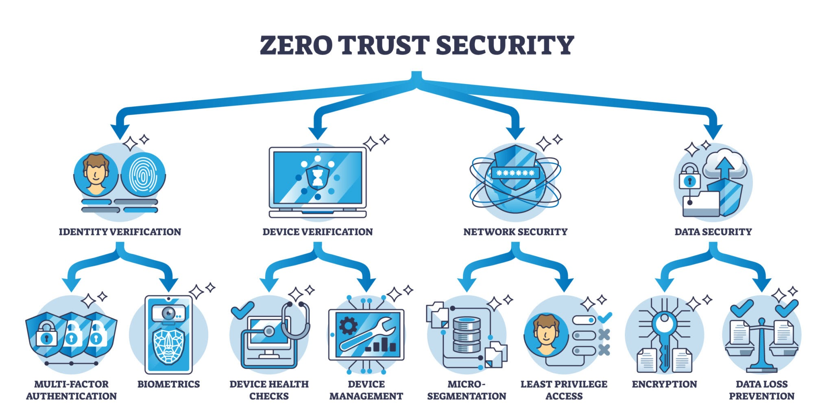
Traditional perimeter security is insufficient for distributed AI systems. A Zero Trust approach ensures that no user, device, or AI agent is inherently trusted, regardless of location (Obsidian Security, 2024).
- Measure: Enforce Zero Trust with Multi-Factor Authentication for all AI Access.
- Mitigation Focus: Unauthorised Access, Data Breaches, Model Theft.
- Action: Use MFA for all human access to AI development environments, model repositories, and sensitive data. Crucially, apply the principle of least privilege to AI agents and models, granting them only the minimum access rights required for their specific function (Microsoft, 2025).

3. Adversarial Training and Continuous Model Monitoring
AI models must be made resilient to attack and their behaviour constantly observed to detect deviations from the norm (Obsidian Security, 2024).
- Measure: Embed Adversarial Testing and Real-time Anomaly Detection.
- Mitigation Focus: Adversarial Attacks, Unpredictable Behaviour, Prompt Injection.
- Action: Incorporate adversarial training into the model development phase to proactively fortify the model against manipulated inputs. Post-deployment, implement real-time monitoring tools to establish a behavioural baseline for the AI system and flag any suspicious input patterns, output anomalies, or significant model drift for immediate human review (Palo Alto Networks, 2025).

Conclusion
AI presents undeniable value, but its unique vulnerabilities necessitate a dedicated security strategy. By prioritising data governance, enforcing Zero Trust access controls, and building model resilience through adversarial testing, enterprises can effectively mitigate the most critical security and ethical risks, ensuring the trustworthy and responsible deployment of AI systems.

References
Clio. (2023) AI and Law: What are the Ethical Considerations? Available at: https://www.clio.com/resources/ai-for-lawyers/ethics-ai-law/ (Accessed: 15 December 2025).
Grant Thornton. (2023) Cybersecurity strategies to mitigate AI risks. Available at: https://www.grantthornton.ie/insights/factsheets/cybersecurity-strategies-to-mitigate-ai-risks/ (Accessed: 15 December 2025).
HBS Online. (2024) 5 Ethical Considerations of AI in Business. Available at: https://online.hbs.edu/blog/post/ethical-considerations-of-ai (Accessed: 15 December 2025).
Microsoft. (2025) Microsoft Guide for Securing the AI-Powered Enterprise: Getting Started. Available at: https://www.microsoft.com/en-us/security/security-insider/emerging-trends/ai-security-guide (Accessed: 15 December 2025).
Mindgard. (2025) AI Risk Mitigation: 6 Proven Strategies to Secure Your AI Systems. Available at: https://mindgard.ai/blog/ai-risk-mitigation-strategies (Accessed: 15 December 2025).
NCSC.GOV.UK. (2024) AI and cyber security: what you need to know. Available at: https://www.ncsc.gov.uk/guidance/ai-and-cyber-security-what-you-need-to-know (Accessed: 15 December 2025).
Obsidian Security. (2024) The Top AI Security Risks Facing Enterprises in 2025. Available at: https://www.obsidiansecurity.com/blog/ai-security-risks (Accessed: 15 December 2025).
Palo Alto Networks. (2025) AI Risk Management Framework. Available at: https://www.paloaltonetworks.co.uk/cyberpedia/ai-risk-management-framework (Accessed: 15 December 2025).
Wiz. (2025) 7 Serious AI Security Risks and How to Mitigate Them. Available at: https://www.wiz.io/academy/ai-security/ai-security-risks (Accessed: 15 December 2025).

